Application Form

Aleksander Gwagnin i jego kroniki (Alexander Gwagnin and his chronicles)
(Łódź, September 16–17, 2024)
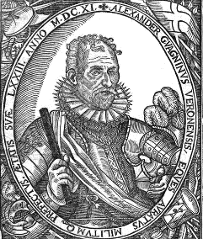

Full Name
Title and academic degree
University/institution
Address and Tax Identification Number of the university/institution to which the invoice is to be issued
Email
Phone
Title of the paper
Abstract (max 1500 characters including spaces)

I hereby give consent for my personal data to be processed for the purposes and procedures required by conference organizing committee, in compliance with the requirements arising from the Personal Data Protection Act.

Full Name

